DC Brushless Water Pump
- Product Parameter
Model  Character |  |  | HM2504-1
Working voltage range |  |  | 5VDC-24VDC
Optional rated power |  |  | 0.5~3W
Optional static water head |  |  | 0.5~2 meters
Optional static flow rate |  |  | 0.5 ~ 3L/min
Lifespan |  |  | Continuous operation under normal working surrounding＞20000H
Working Environment |  |  | PH value: PH5-10(weak acid and weak base), workable in water and on land.
Max noise |  |  | Under normal working condition,(1meter over the test instrument)＜30dB
Other optional special functions |  |  | Water shortage protection, over-voltage protection, over-current protection, blocking protection, 0-5V speed control, PWM speed control, FG signal feedback, etc.
Max working temperature |  |  | Under room temperature surroundings, fluid medium temperature≤70℃
Application |  |  | Water dispenser, humidifier, pet drinking water dispenser, small fountain, aquarium, solar water circulation system, soilless cultivation, hydropnics, Decorative potted plants,foot bath basin, small medical equipment, crafts, etc.
Color |  |  | White (Can be customized according to customer`s requirement)
Outlet direction |  |  | Can be adjustable at any angle
Dimension |  |  |  | IP grade | Inlet |  | Outlet |  | Remarks
Length（mm） | Width（mm） | Height（mm） |  | IP grade | OD（mm） | ID（mm） | OD（mm） | ID（mm） | Outlet have anti-slip strip
49.2 | 35.5 | 36.5 |  | IP68 | 12.0 | 9.0 | 8.0 | 5.0 | Outlet have anti-slip strip
- Outside View
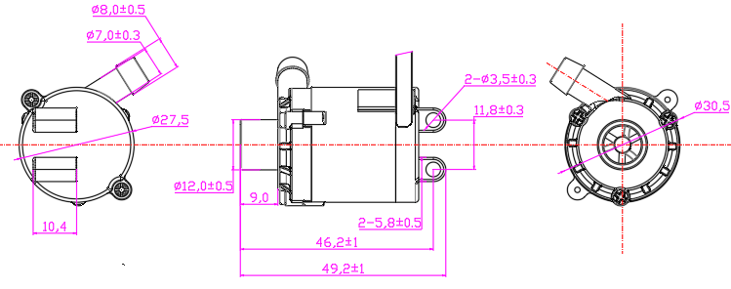

- Curve Graph
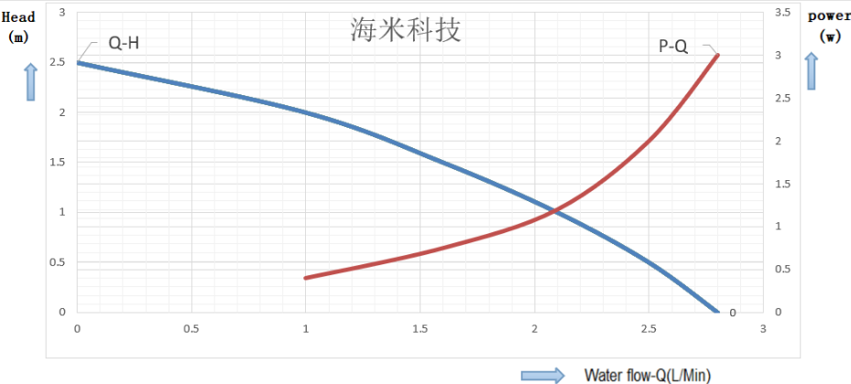

Remarks: The graph is just for your reference, the final one comes with the customer required specifications.
- Photo for you reference
