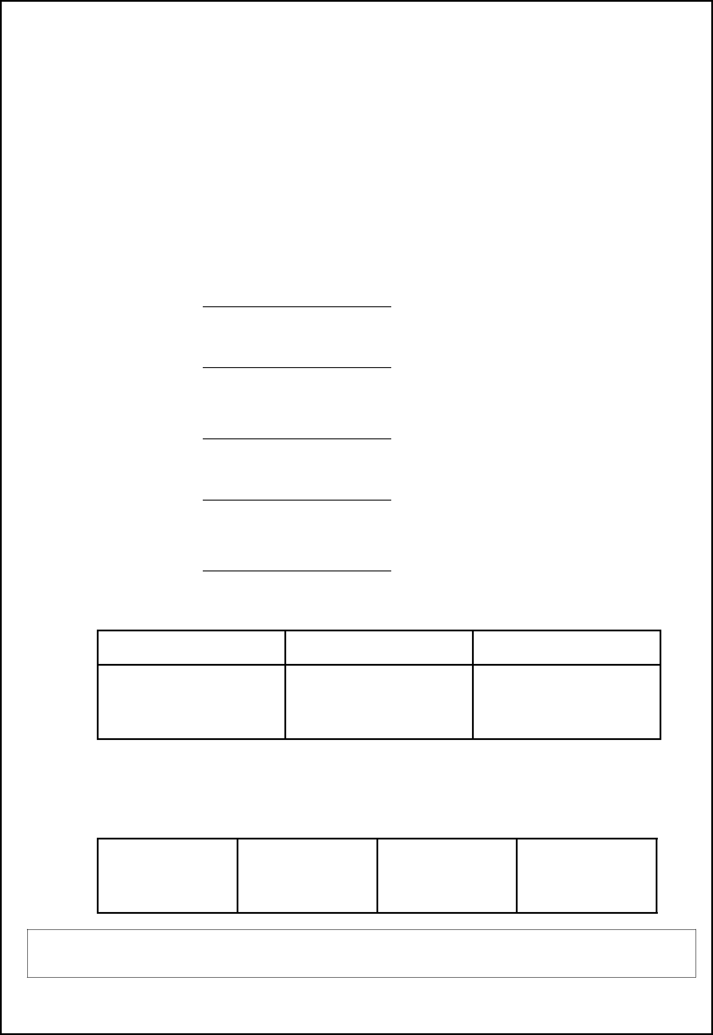
型号/model：HM370-12A-1 产品规格书

Specifications

页次/page： 1／7

版本号/Version number：A/0

东莞市海米电子科技有限公司

Dongguan Hai Mi Electronic Technology Limited.

水泵规格书

Specification of water pump

客 户：

Customer

品 名：直流水泵

Part name: Dc water pump

型 号： HM370-12A-1

Model

日 期：2022-01-25

Date

页 数：共 7 页（包括封面）

Number of pages: Seven pages

作成/Made | 审核/Audit | 核准/ Approval

何娟

客户承认

Customer acknowledgment

东莞市海米电子科技有限公司

Dongguan Hai Mi Electronic Technology Limited.


型号/model：HM370-12A-1 产品规格书

Specifications

1. 适用范围 Application：

页次/page： 2／7

版本号/Version number：A/0

本规格书适用 HM370-12A-1 水泵 之用.

The specifications apply HM370-12A-1 use。

2. 测试环境 Standard test environment:

2-1 | 测试环境温度 | 周围温度 20℃相对湿度 65%RH 为标准，如无争议发生可以在下
 | Environment test | 述环境测试：周围温度 5-30℃相对湿度 40-85%RH。
 |  | The standard of environment test is the ambient temperature of 20℃
 |  | and relative humidity of 65%RH. lf no disputes occur,the test can be
 |  | conducted under the blow circumstance: the ambient temperature of
 |  | 5~30℃ and relative humidity of 40~85%RH.
2-2 | 测試姿势（Position） | 水平（Horizontal）
2-3 | 额定负载（Load） | 抽水扬程 15 厘米（water absorption head 15cm）
2-4 | 使用温度范围 | 5 ~45ºC(Humidity to 30% to 85%RH)
 | Operation temperature range
2-5 | 保 存 温度 范 围 Preservation | -20 ~60ºC(Humidity to 30% to 85%RH)
 | temperature range

3 电气特性 Electrical characteristics:

3-1 | 额定电压 Rated voltage | DC 12V
3-2 | 使用电压范围 | DC 9V~14.4V
 | Operating voltage range:
3-3 | 额定电流 Rated current | 供电 DC 12V，抽水时的最高电流＜700mA | ＜700mA
 |  | The highest voltage should be less than 700mA | Less than
 |  | when the pump drawing water with DC 12V. | 700mA
3-4 | 负载流量 Load Flow | 在 DC 12V，高度在 15cm 范围内抽水量大于或 | ≥1000 mL/min
 |  | 等于 1000 mL/min. | more than or equal
 |  | At DC 12V ,the pump discharge in the range of | to 1000 mL/min
 |  | more than or equal to 1000 mL/min, when the
 |  | pump at the plane of 15cm（height）.
3-5 | 噪音 Noise | 下垫 5cm 之海綿, 距噪音计 30cm 之处, 依 DC | ＜65dB
 |  | 12V 之电源，吸水时噪音小于 65dB | Less than
 |  | Putting a 5 cm sponge under the pump, and | 65dB

东莞市海米电子科技有限公司

Dongguan Hai Mi Electronic Technology Limited.

型号/model：HM370-12A-1 产品规格书

Specifications

页次/page： 3／7

版本号/Version number：A/0

 |  | placing it about 30 cm away from the noise meter,
 |  | Suction noise less than 65dB with DC 12V .
3-6 | 启动电压 Starting voltage | 输入 9V 之电压可使水泵启动. | DC 9V
 |  | The input voltage of DC 9V can make the pumps
 |  | are turned on.

在经过以下 4-1 至 4-5 和 5-1、5-2 项目测试后，产品须可满足项目 3-3，3-4,3-6,之基本性能。但是噪音＜65dB即为合格。

After the pump has been tested through test 4-1 to 4-5 and 5-1 、 5-2, it must be suitable the basic performance required by item 3-3，3-4,3-6,.However，it to be OK that the dropped pressure value shall be noise level shall be less than 78dB.

4 环境试验 |  |  | Environmental Tests：
 | 4-1 |  | 低温放置试验 | 放置在-20℃经 72 小时后, 再取出置于常温(20±5℃)中 2 小
 |  |  | Low-temperature characteristic | 时依下列专案测试无异状 3-3，3-4，3-6.
 |  |  |  | Putting the pump in the temperature at negative 20 ℃ for 72
 |  |  |  | hours; then taking it out and putting it in a room temperature at 20±
 |  |  |  | 5℃ for 2 hours, Under this circumstance, running through test 3-3，
 |  |  |  | 3-4，3-6 .and finding out that the pump still performs well.
 | 4-2 |  | 高温放置试验 | 在 60℃经 72 小时放置后, 在放常温(20±5℃)中 2 小时依下
 |  |  | High-temperature | 列专案测试无异状 3-3, 3-4,3-6.
 |  |  | characteristic | Putting the pump in the temperature at 60℃ for 72 hours; then taking
 |  |  |  | it out and putting it in a room temperature at 20 ± 5 ℃ for 2 hours,
 |  |  |  | Under this circumstance, running through test 3-3 ， 3-4 ， 3-6.and
 |  |  |  | finding out that the pump still performs well.
 | 4-3 |  | 高温高湿放置试验 | 在温度 60℃,湿度 95%环境中经 72 小时取出置于常温(20±
 |  |  | High-temperature & High | 5℃)中 2 小时依下列专案测试无异状 3-3，3-4，3-6.
 |  |  | humidity | Putting the pump in the temperature at 60℃ and the humidity at
 |  |  |  | 95% for 72 hours; then taking it out and putting it in a room
 |  |  |  | temperature at 20 ± 5 ℃for 2 hours. Under this circumstance,
 |  |  |  | running through test 3-3，3-4，3-6. and finding out that the pump still
 |  |  |  | performs well.
 | 4-4 |  | 温湿度循环放置测试 | 在经过 12 次的温湿度循环测试后:-20℃* 2Hr → +25℃* 1Hr

东莞市海米电子科技有限公司

Dongguan Hai Mi Electronic Technology Limited.

型号/model：HM370-12A-1 产品规格书

Specifications

页次/page： 4／7

版本号/Version number：A/0

 | Temperature & humidity cycle | →+60℃ 85%RH* 2Hr →+25℃*1Hr,需维持相同的性能.依下列
 | test | 专案测试无异状 3-3 ， 3-4 ， 3-6.After doing the temperature and
 |  | humidity cycle test,-20℃* 2Hr → +25℃* 1Hr→+60℃ 85%RH*
 |  | 2Hr →+25℃*1Hr,for twelve times, the pump shall still perform the
 |  | same functions proved by running through test 3-3，3-4，3-6.
4-5 | 寿命试验 | DC 12V，抽水扬程 15cm 抽水 40 秒，停 20 秒为一个循环，
 | Life test | 测试 500 小时以后经下列专案测试无异状 3-3，3-4，3-6.
 |  | DC 12V water absorption head 15cm, pumping 40 seconds on,
 |  | 20 seconds for a loop test 500 hours after no abnormal test by
 |  | following project 3-3,3-4,3-6.

5 特殊环境测试 Thermal test performance:

5-1 | 低温环境测试 | 在温度 0℃经五小时后,立即在此温度下依下列专案测试无异
 | Low-temperature environment | 状，3-3，3-4，3-6,
 | test | Under a temperature of 0 ℃ for 5 hours, then examining the
 |  | pump by test 3-3，3-4，3-6 and finding out it still perform well.
5-2 | 高温环境测试 | 在温度 50℃经五小时后,立即在此温度下依下列专案测试无
 | High-temperature environment | 异状，3-3，3-4，3-6.
 | test | Under a temperature of 50 ℃ for 5 hours, then examining the
 |  | pump by test 3-3，3-4，3-6 and finding out it still perform well.

6 其它 Others:

6-1 | 端子强度 | 以 0.5 公斤法码与端子平行负载无异常者.
 | The lead tension | Hanging a 0.5 Kg static load on the terminal of the pump will
 |  | not cause damage on the pump.
6-2 | 落下实验 | 使用标准的包装方式,在水泥地上将其从 50cm 的高度分别从
 | Fall test | 正面,侧面,及边角落下,其性能及结构需无异常.
 |  | Basic performance and the struture shall not be defected after
 |  | following test; With a standard packaging conditions, then dropping it
 |  | at the front,side,and edges part from the height of 50 cm to the
 |  | concrete floor.
6-3 | 外观 Appearance | 产品无不适当的外观和刮伤, 脏污…等.
 |  | The appearances of the pump shall not contain cracks and

东莞市海米电子科技有限公司

Dongguan Hai Mi Electronic Technology Limited.

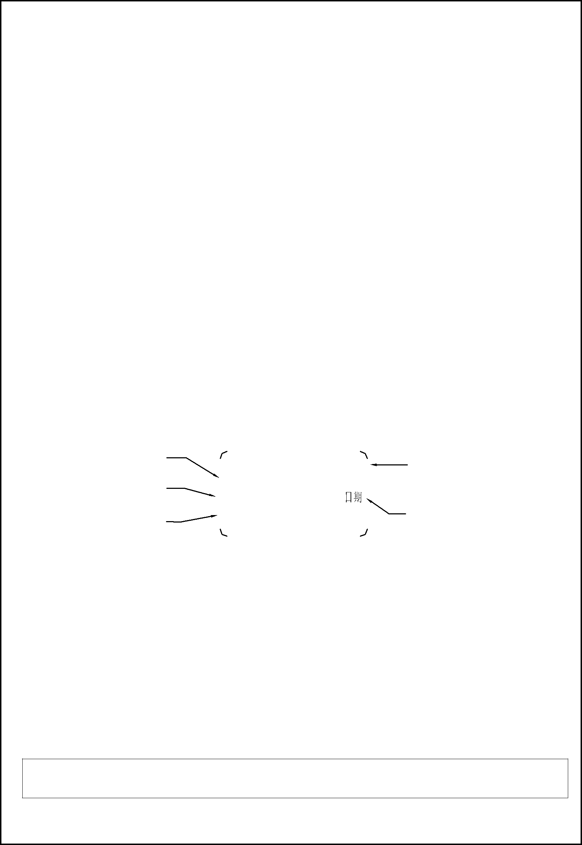
型号/model：HM370-12A-1 产品规格书

Specifications

页次/page： 5／7

版本号/Version number：A/0

 |  | impurities.
6-4 | 异常试验 Unusual test | 以 DC14.4V，堵住出气孔，全负载连续 8 小时通电无燃烧,
 |  | 发烟现象.
 |  | There is no burning and smoking occurrence while the power is
 |  | on with DC 14.4V，full load， for 8 hours continuously.
6-5 | 焊锡要求 | 马达端子焊锡作业需在焊锡温度 380℃下,2 秒内操作完成.
 |  | Motor terminal for Soldering process the heat temp. is controlled
 |  | by 380℃,and operating time is for 2 sec only.

7 标签内容示例（也可按客户要求提供）： Labels（Also can be customized.）:

Brushless DC Water Pump
Model: HM370-12A-1
Input: DC12V 10W
Hmax: 2000cm
Qmax: 60L/H
Made In China

东莞市海米电子科技有限公司

Dongguan Hai Mi Electronic Technology Limited.
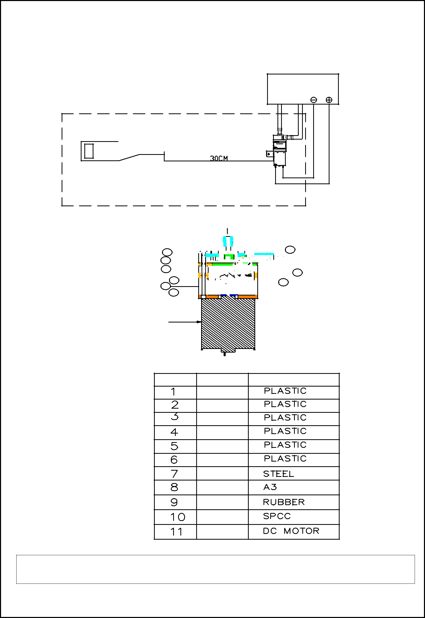
型号/model: HM370-12A-1 产品规格书

Specifications

8 噪音测试线路图 Noise test circuit diagram:

页次/page： 6／7

版本号/Version number：A/0

检查仪器

inspection equipment

噪音测试仪

NOISE METER

MINI PUMP

YUNT:JSB2438088

VOLTAGE:DC 12V 年 月 日

5cm厚的海绵垫

5cm THICK SPONGE

9 结构图 Structural drawing:

₈  1

- 
-  9
- ₆⁷ 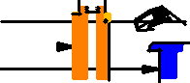 ⁵

1 0

10 材料表 Material list:

号 码 名 称 N A M E . 材 料 M A T E R I A L .

塑 胶

塑 胶

塑 胶

塑 胶

塑 胶

塑 胶

钢 针

螺 丝

橡 胶

支 架

马 达

东莞市海米电子科技有限公司

Dongguan Hai Mi Electronic Technology Limited.

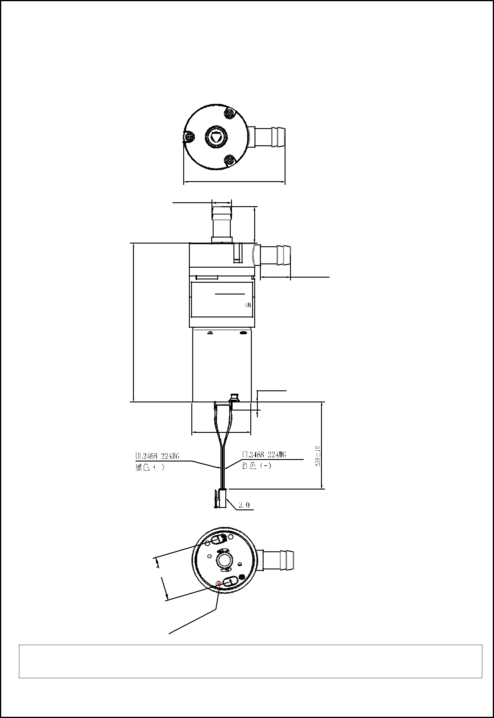
型号/model：HM370-12A-1 产品规格书

Specifications

11.成品外形图 Finished Outline

页次/page： 7／7

版本号/Version number：A/0

5±1.065.

41.5±1.0

8.0±0.3

0±0.515.

12.5±0.3

4.0±0.5

(-) (+)

24.2±0.5

18.0±0.3

 |  |  |  |  |  |  |  |  | t
 |  |  |  |  |  |  |  |  | o
 |  |  |  |  |  |  |  | d
 |  |  | 极 |  |  |  | d
 |  |  |  |  |  |  | e
 | 正 |  |  |  |  | e | r
点 |  |  |  |  | v
红 |  |  |  | i
红 |  |  | t
 |  | i
 | s
o
P

东莞市海米电子科技有限公司

Dongguan Hai Mi Electronic Technology Limited.

