DC Brushless Water Pump
- Product Parameter
Model  Character |  |  | HM2502-1
Working voltage range |  |  | 5VDC-12VDC
Optional rated power |  |  | 0.5~3W
Optional static water head |  |  | 0.5~2.5 meters
Optional static flow rate |  |  | 0.5 ~ 2.5L/min
Lifespan |  |  | Continuous operation under normal working surrounding＞20000H
Working Environment |  |  | PH value: PH5-10(weak acid and weak base), workable in water and on land.
Max noise |  |  | Under normal working condition,(1meter over the test instrument)＜35dB
Other optional special functions |  |  | Water shortage protection, over-voltage protection, over-current protection, blocking protection, 0-5V speed control, PWM speed control, FG signal feedback, etc.
Max working temperature |  |  | Under room temperature surroundings, fluid medium temperature≤100℃
Application |  |  | (Automatic) Coffee machine, automatic teapot, juice extractor, beverage machine, wine set, water dispenser, humidifier, pet drinking water dispenser, small fountain, aquarium, solar water circulation system, soil-less cultivation, foot bath basin, crafts, etc.
Color |  |  | Black (Can be customized according to customer`s requirement)
Outlet direction |  |  | Can be adjustable at any angle
Dimension |  |  |  | IP grade | Inlet |  | Outlet |  | Remarks
Length（mm） | Width（mm） | Height（mm） |  | IP grade | OD（mm） | ID（mm） | OD（mm） | ID（mm） | Inlet and outlet have anti-slip strip
41.5 | 26.2 | 37.0 |  | IP67 | 10.0 | 7.0 | 7.0 | 4.0 | Inlet and outlet have anti-slip strip
- Outside View
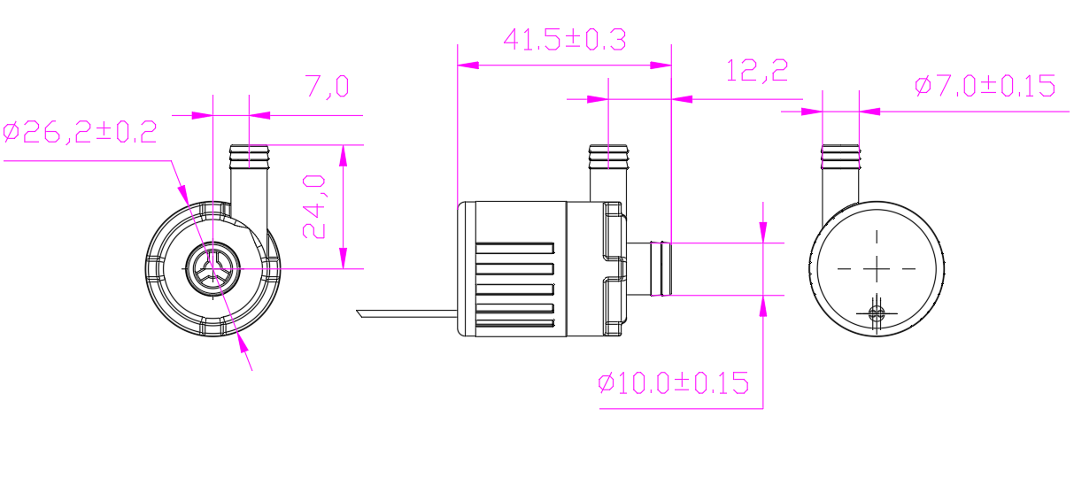

- Curve Graph
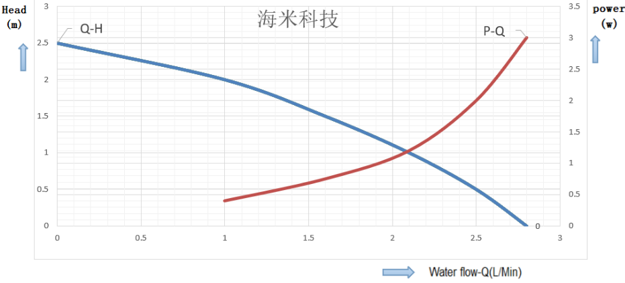

Remarks: The graph is just for your reference, the final one comes with the customer required specifications.
- Photo for you reference
